**LIBRARY MANAGEMENT SYSTEM UML DIAGRAMS**

**K ramya chowdary**

**(192011288)**

**1.USE CASE DIAGRAM**

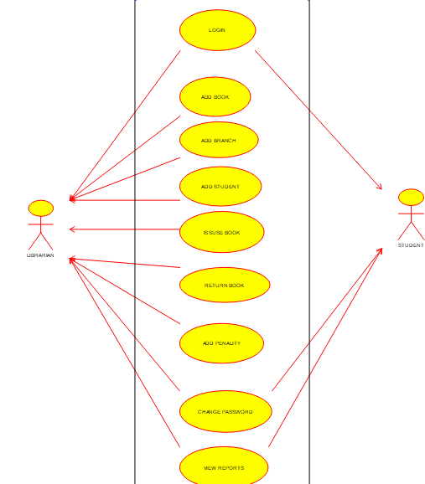

**2.SEQUENCE DIAGRAM**

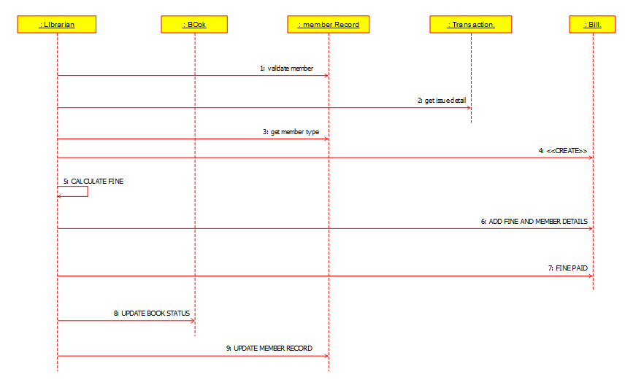

**3.CLASS DIAGRAM**

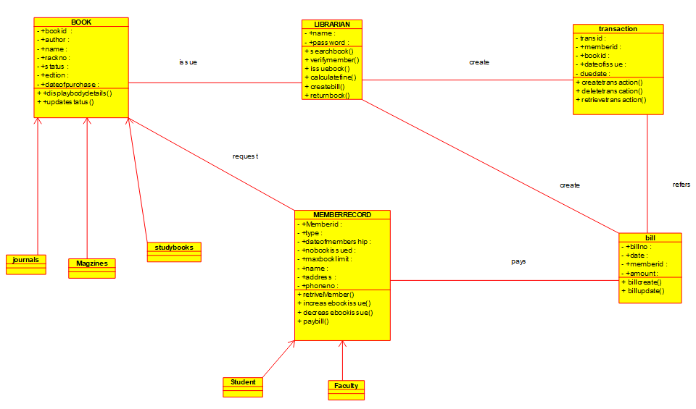

**4.ACTIVITY DIAGRAM**

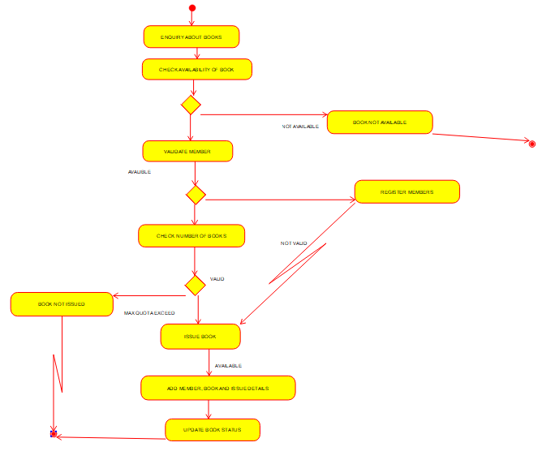

**5.STATE DIAGRAM**

